MySQL Community Server with Workbench and MySQL Shell on macOS

Installation

For this course we are going to use mysql community servers. Please follow the steps:

MySQL Community Server Installation:

- Go to the link: https://dev.mysql.com/downloads/
- From there select the MySQL Community Server
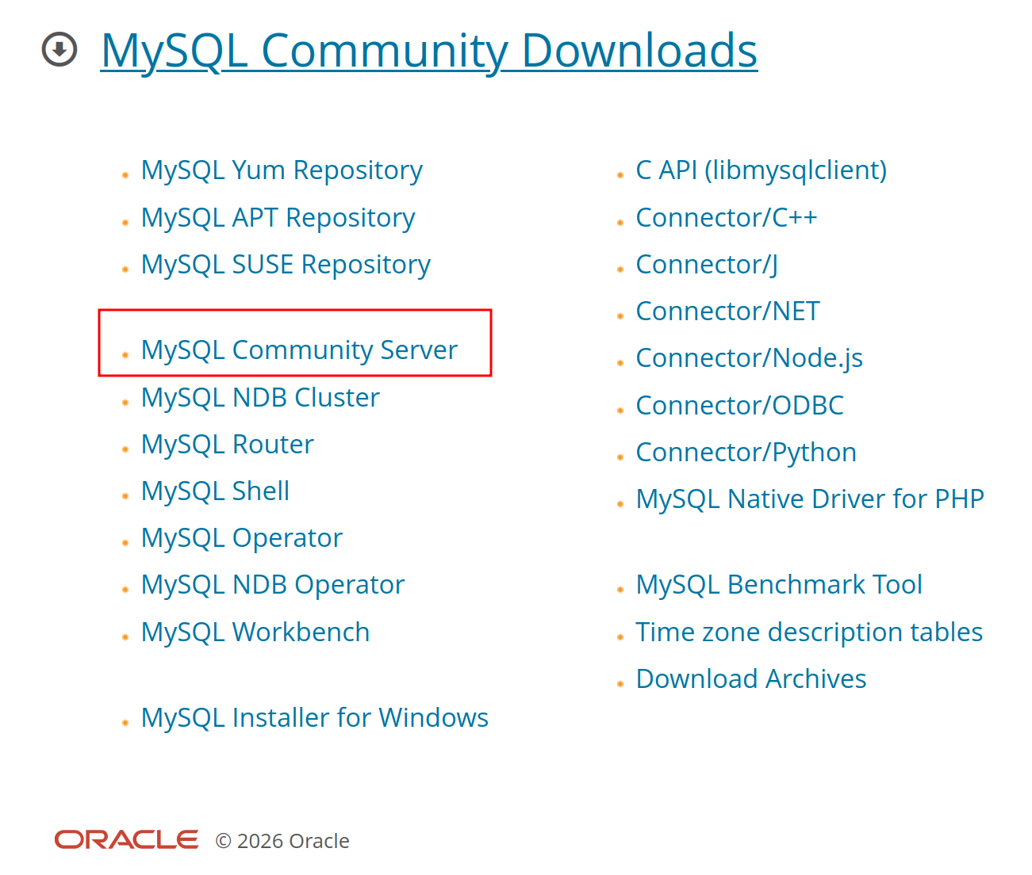

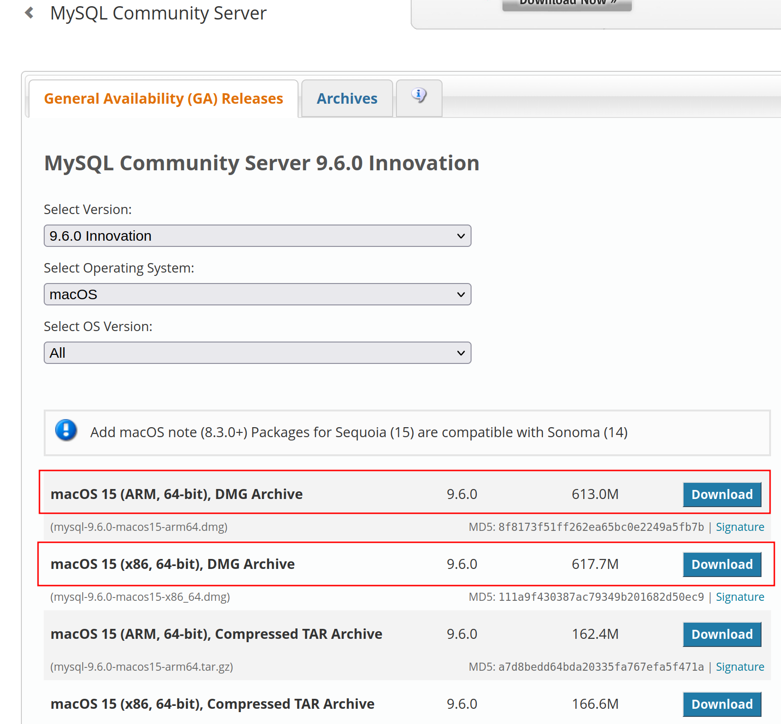
- Download the DMG archive file.

Choose ARM for Apple Silicon chip (if your Macbook after 2020)or x86 if it is intel processor (before 2020)

CAUTION: choose the package compatible with your Mac OS version. e.g. If you do not have macOS 14 or later, the current version is not compatible. Older versions you can find in the ‘Archives’.

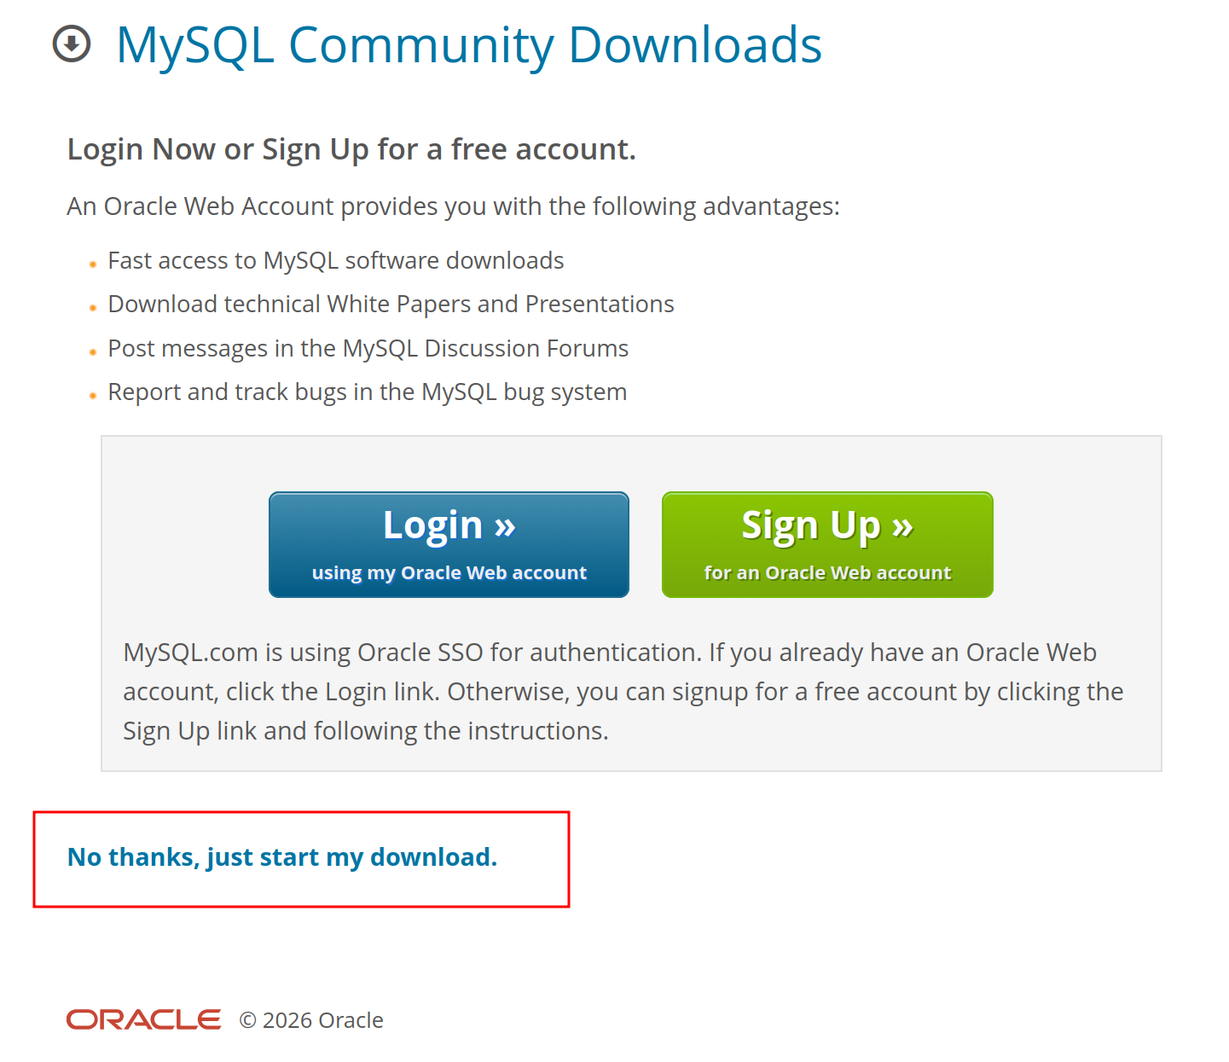

You do not need to have an Oracle account. Click on ‘No, thanks. Just start my download.’

- Then follow the installation procedure. You will be asked to provide a password to complete the installation. It does not have to be the password of your mac. Choose the password wisely for future use.
- Upon completion of installation, go to ‘System Preferences’. If the icon of MySQL is present there it means your installation was successful.

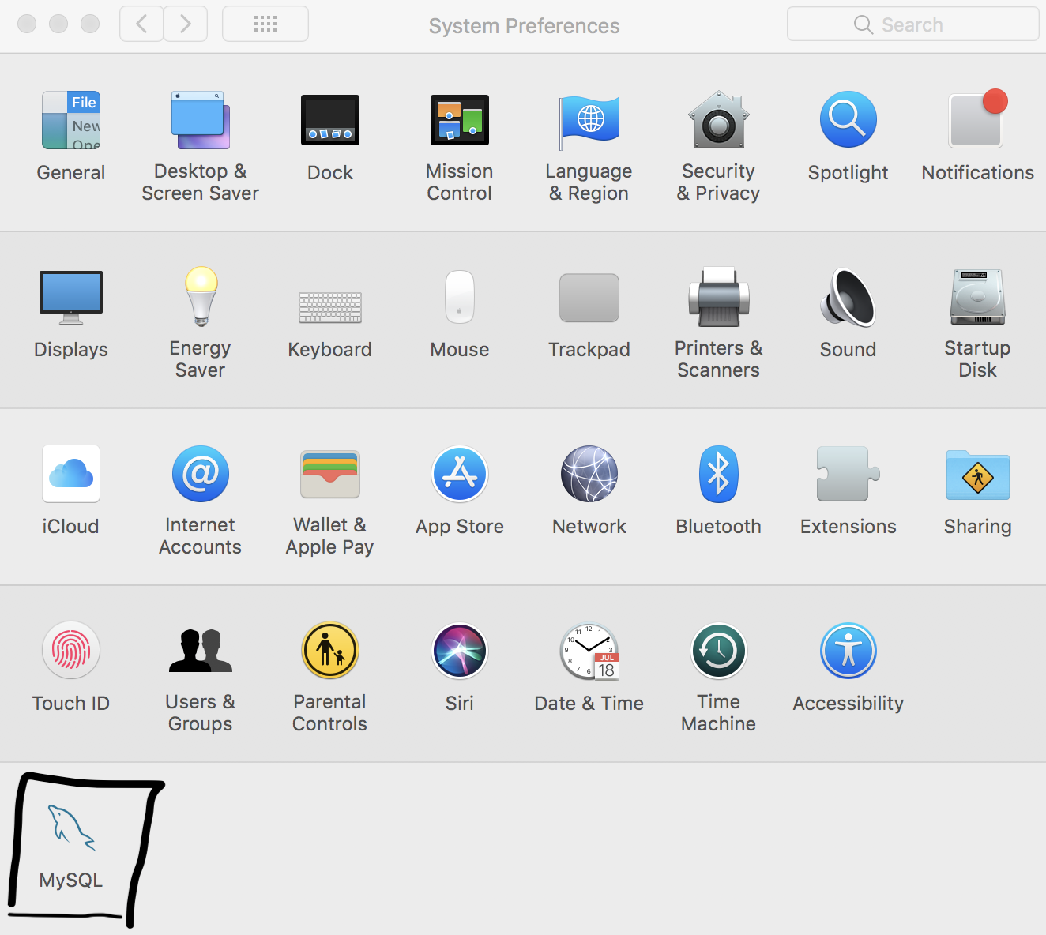

MySQL WorkBench Installation:

- Go to the link below and download the macOS .dmg package.
MySQL :: Download MySQL Workbench

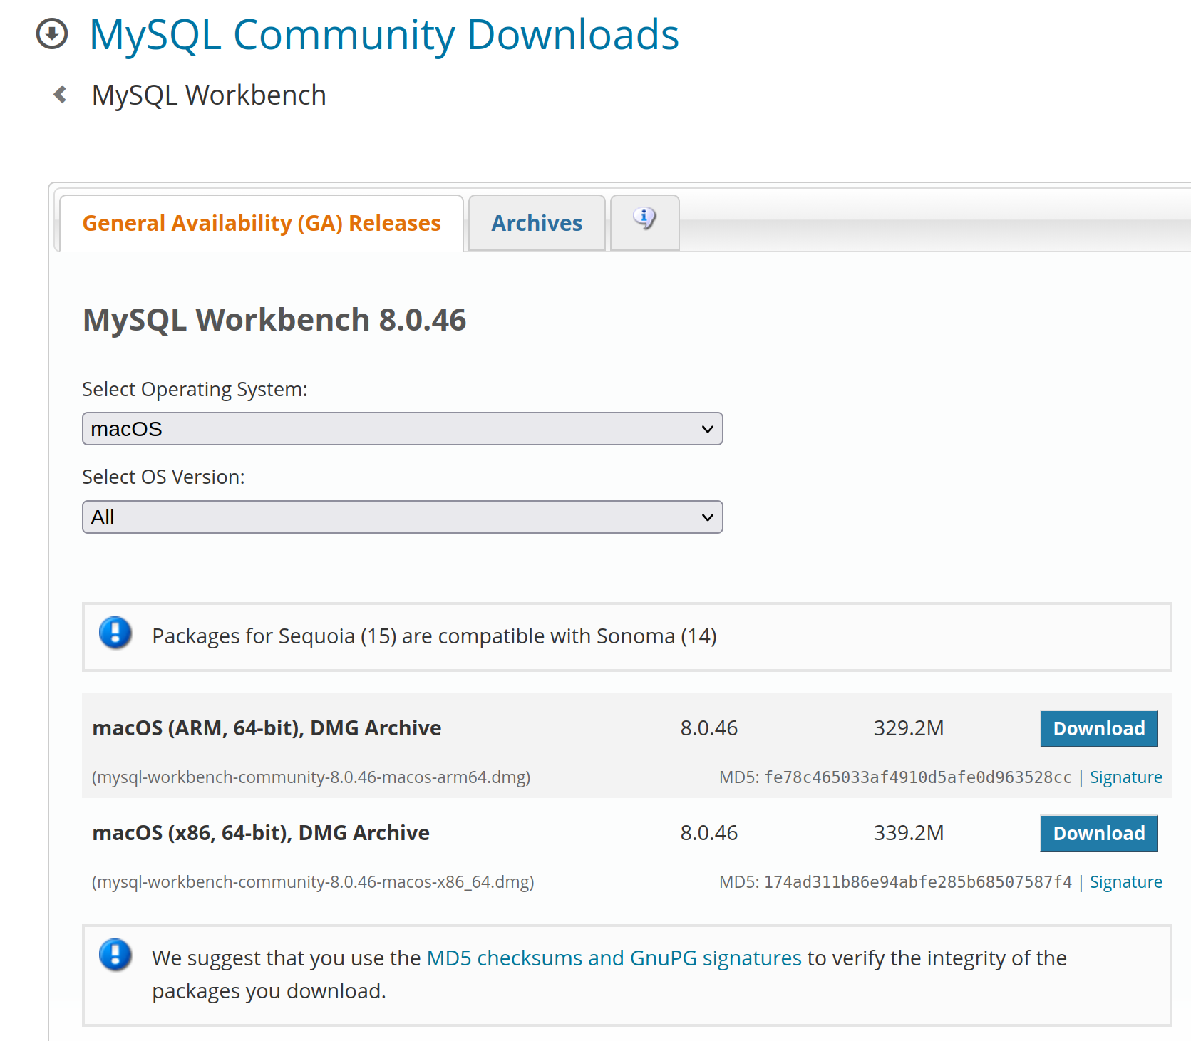

- Open the downloaded package and drag the MySQLWorkbench icon into the desired location. Usually this is the Applications folder.
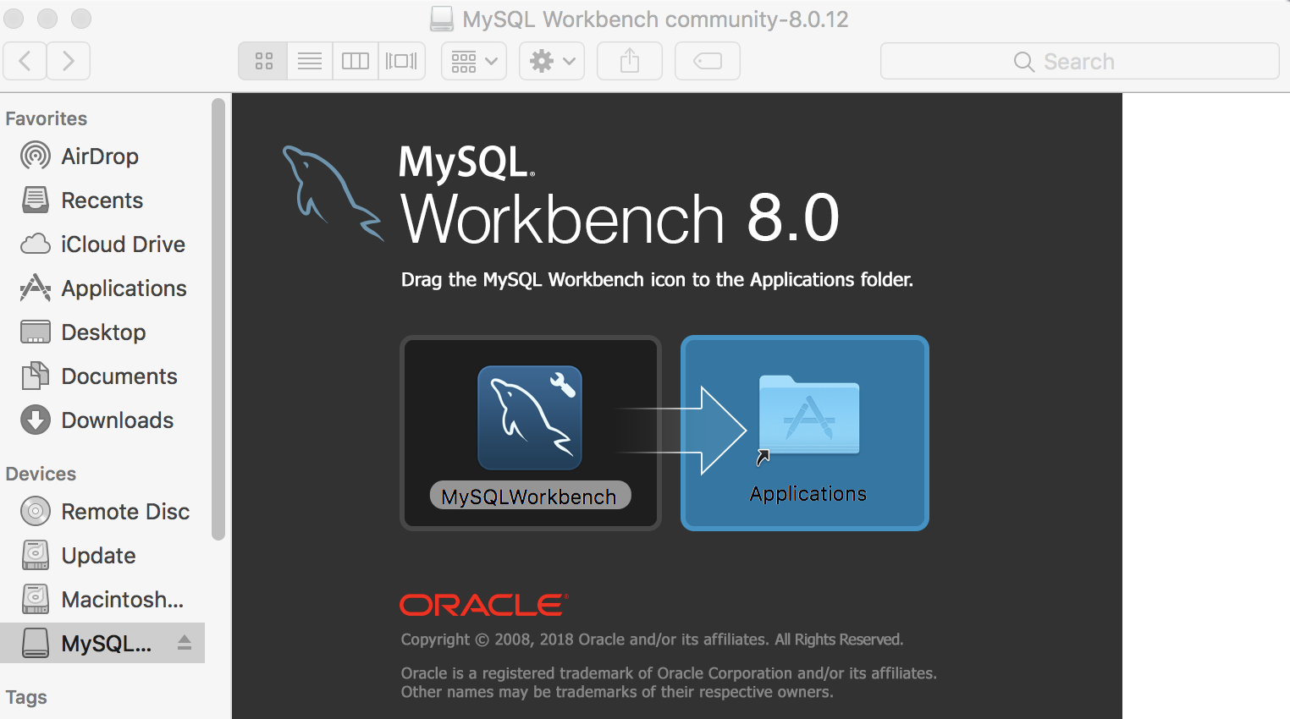

- Now you can try to open MySQL Workbench with spotlight search (⌘ + space).

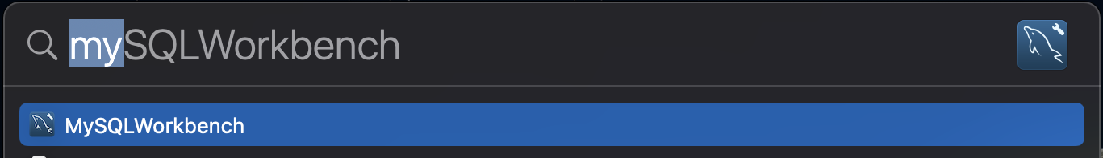

- Now it should be possible to open MySQL Workbench with spotlight search (⌘ + space).
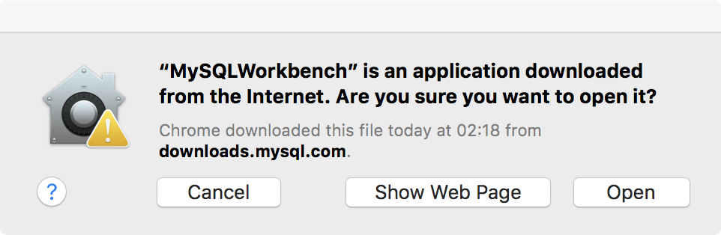

If asks for permission select open

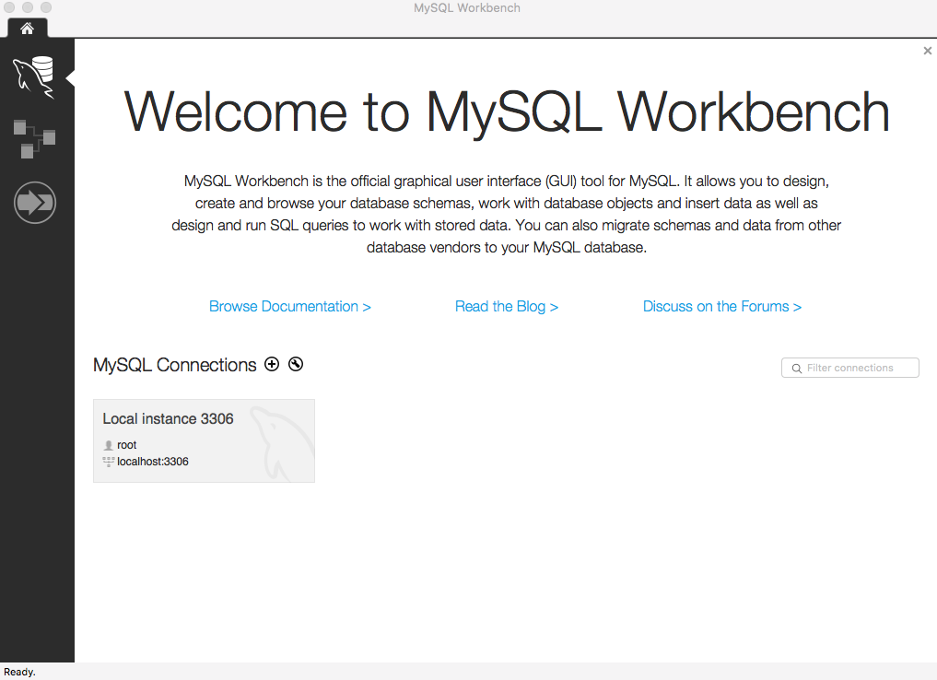
- To test if the installation was complete and able to connect to mysql community server, add a new connection by selecting + beside MySQL Connections. Then add a new connection with the same parameter values (connection method, hostname, port, username). You can use any name for your Connection Name. Select Test Connection and enter your MySQL Community Server Password.

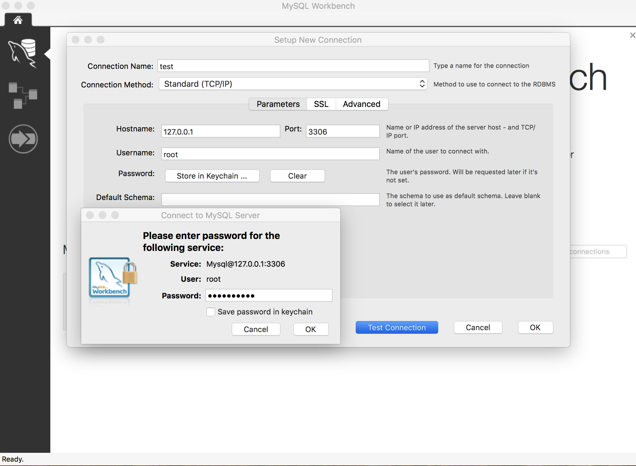

MySQL Shell Installation:

MySQL Shell is a command line interface to connect to mysql servers. The installation steps are as follows:

- Go to the link below and download the macOS .dmg package.
https://dev.mysql.com/downloads/shell/

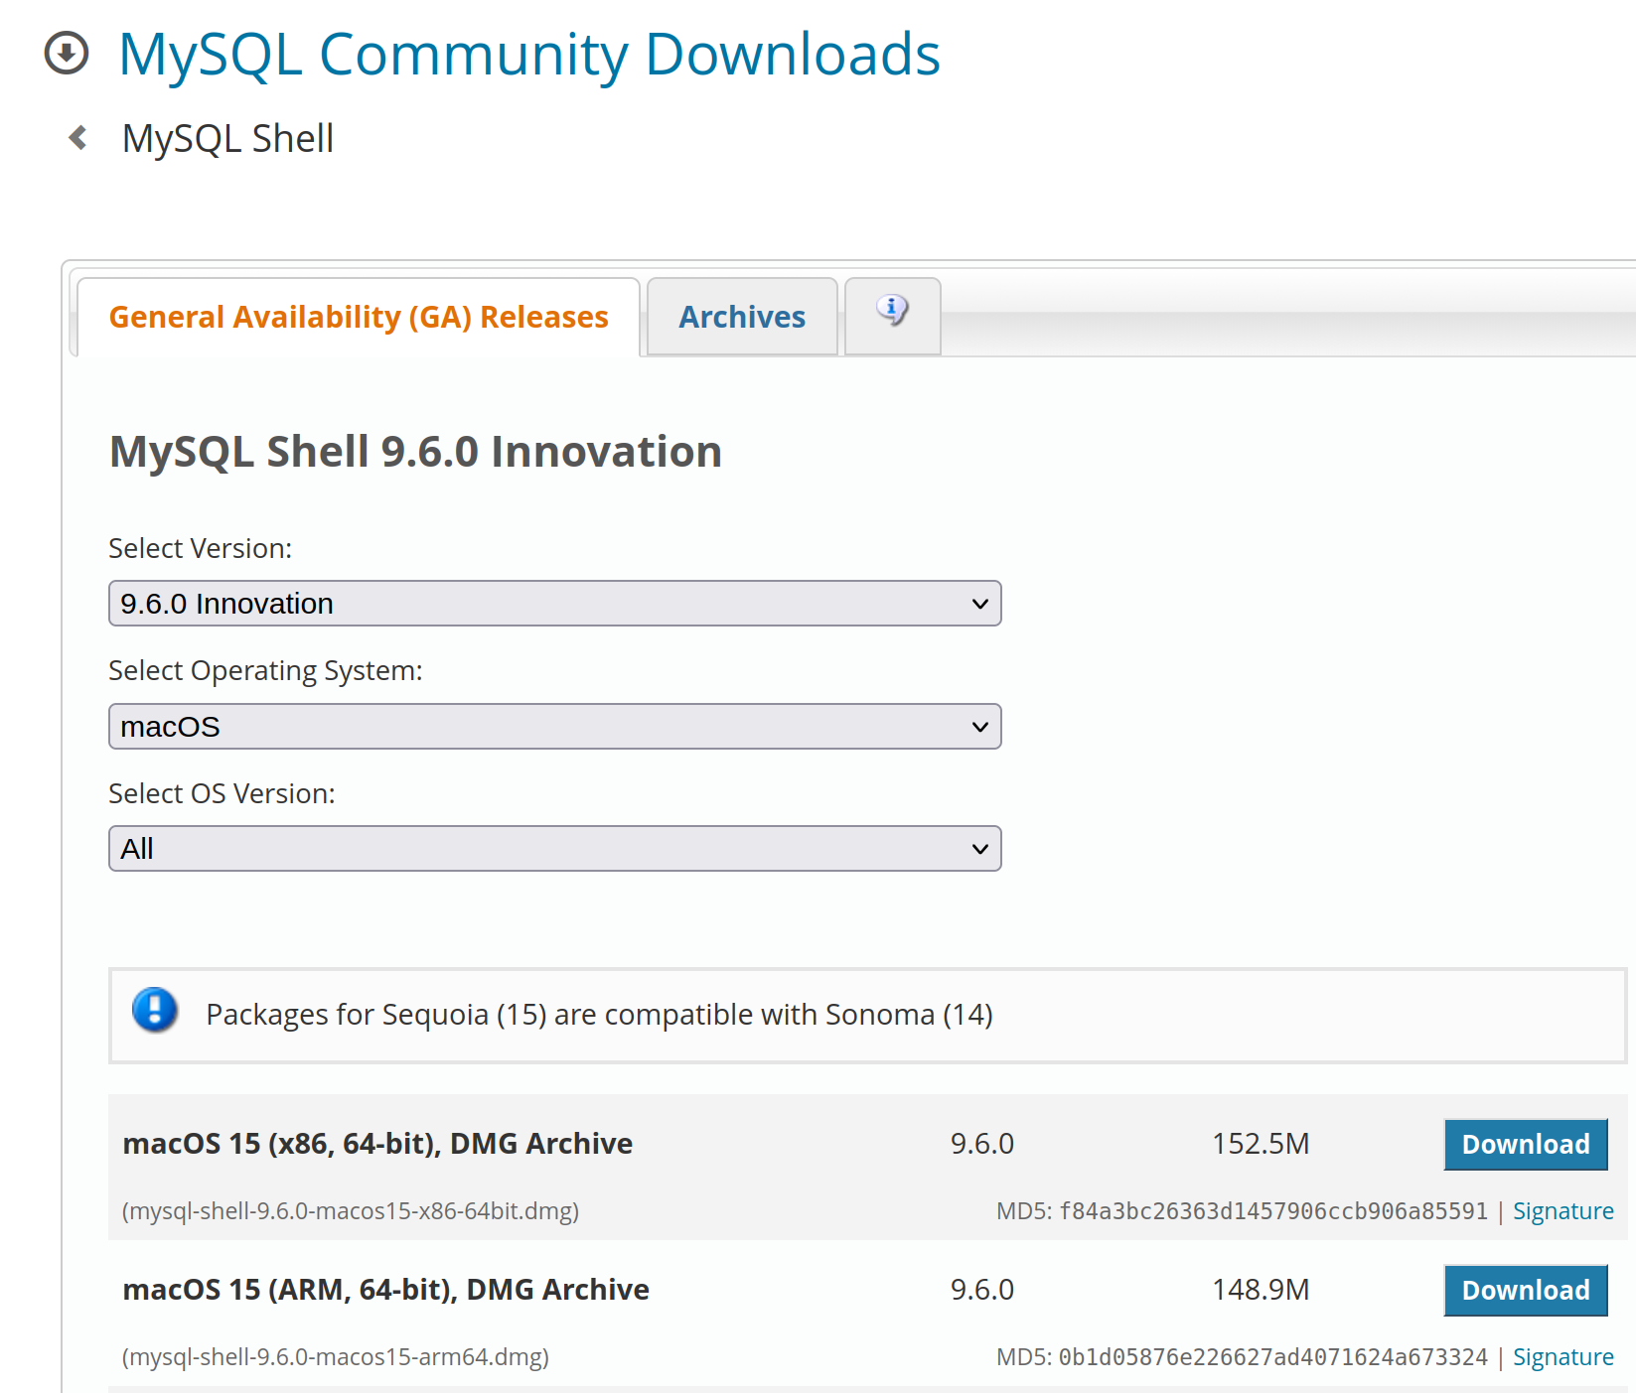

- Open the .dmg file and follow the installation instructions
- After finishing the installation, open Terminal on spotlight search (⌘ + space).
- Type out mysqlsh in the terminal.

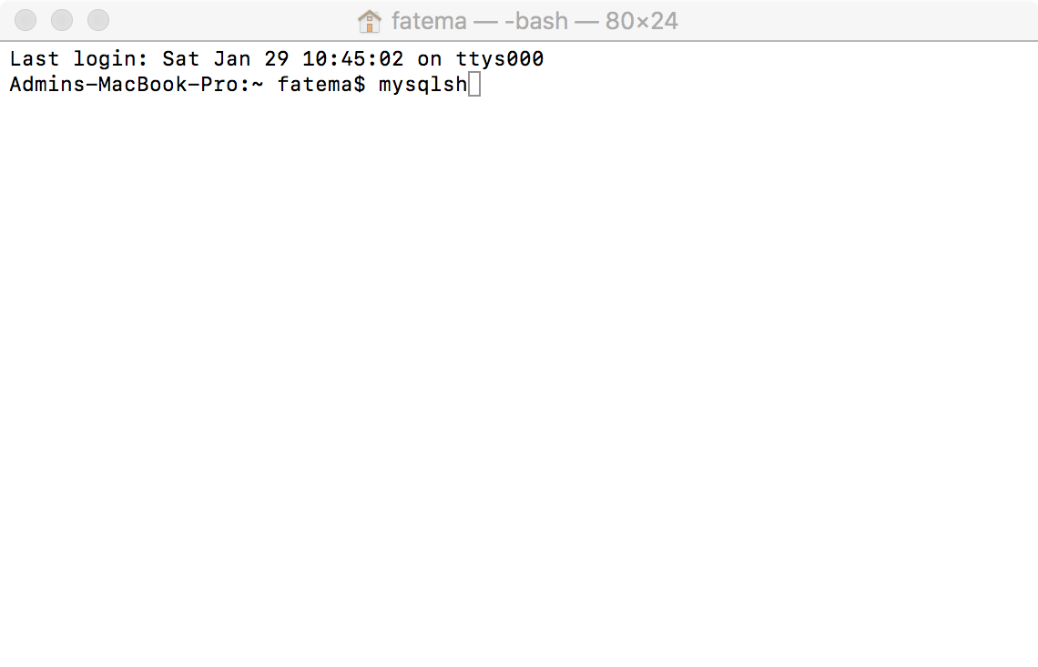

- By default it uses JavaScript. To use sql commands, type \sql
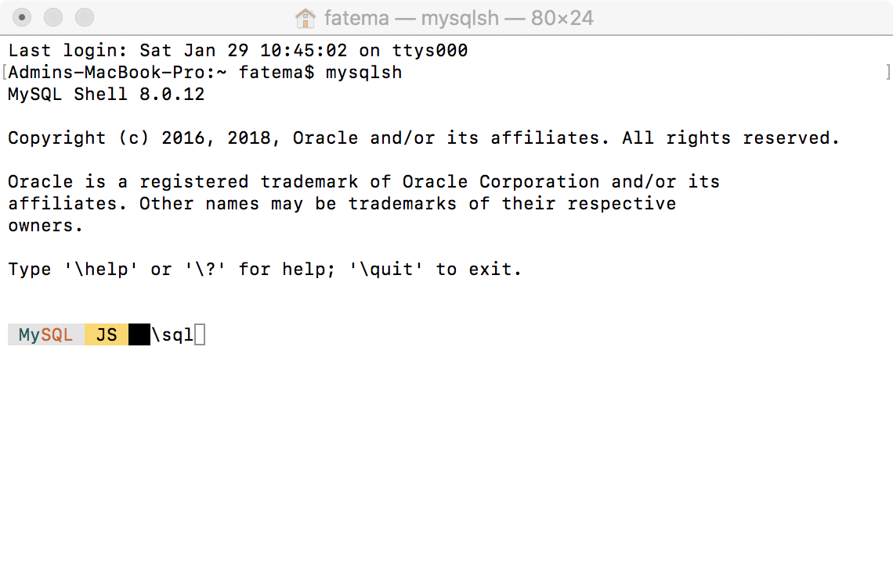
- Now connect your mysql servers by \connect root@localhost:3306 . Provide the password that you used when installed mysql servers.
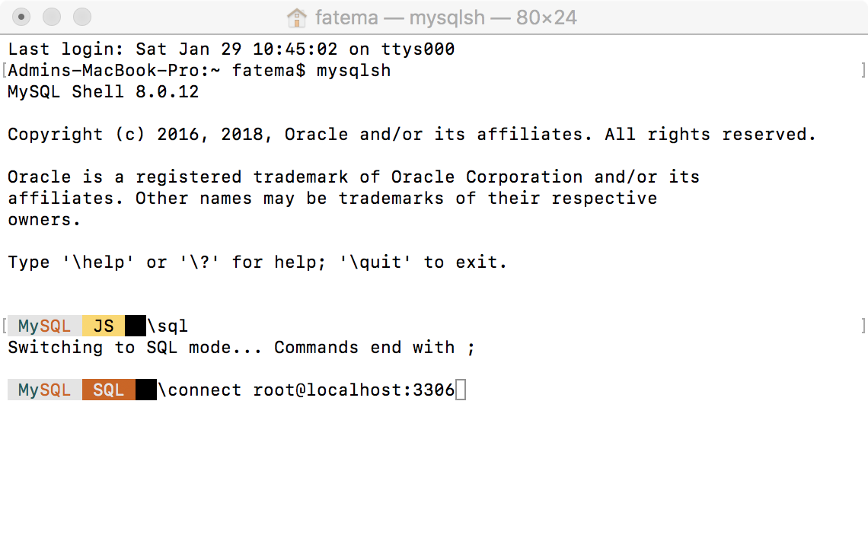

Welcome to your local database server. Now you can perform any SQL queries. For example, Try out,

show databases;

- Do not forget to logout after using mysql shell. type \quit
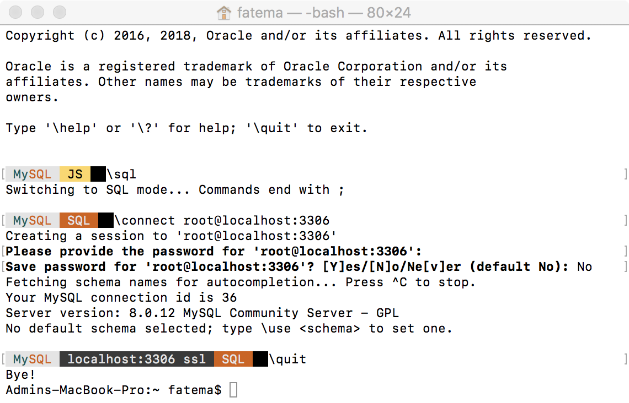

You have to connect your localhost every time you want to use mysql servers using \connect root@localhost:3306. Do not forget to logout after use, using \quit.

